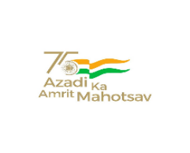  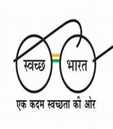 | केंद्रीय विद्यालय रबर बोर्ड कोट्टयम-686009,केरल.  KENDRIYA VIDYALAYA RUBBER BOARD , KOTTAYAM  KERALA- 686009  फोन/ PHONE 04812351807 फाक्स/Fax No: 2351807 ईमेल/Email:kvkottayam@yahoo.co.in  वेब/Web:rbkottayam.kvs.ac.in.

F. II-18/KVKTM/2023-2024/ Date: 25.07.2023

ADMISSION NOTICE(No.4) FOR BAL VATIKA-3 Dated 25.07.2023

CANDIDATES PROVISIONALLY SELECTED UNDER CATEGORY 5
S No. | Application Submission code | Name | Lottery Number/  Wait List Number
1 | 230978892082777277 | DANIEL SAJIMON | 20/WL 43
2 | 230978160701933946 | ADHAV J MADHAV | 21/WL 44
3 | 230978897062780969 | DAKSHITH RATHEESH | 22/WL 45
4 | 230978581722384750 | EVANIA ELIZABETH MATHEW | 23/WL 46

- DATE & TIME for Verification of Documents and Admission: 26/7/2023 from 8:30 am to 10:30 am
2) The following documents should be brought for verification
  - Birth Certificate
  - OBC NCL Certificate (if applicable)
  - Residence Certificate/Proof
  - Print out of the Online Registration Form along with a passport size photograph
  - Aadhar card of the child
  - One set of photocopy of all the Certificates
3) Parents should come to the Vidyalaya (preferably both) along with the child for document verification and completing the admission procedure.
Note:
Formats of service certificate, transfer certificate and distance declaration can be downloaded from the website.

PRINCIPAL

