പിഎം ശ്രീ കേന്ദ്രിയ വിദ്യാലയ റബ്ബർ ബോർഡ് കോട്ടയം
पीएम श्री केंद्रीय विद्यालय, रबड़ बोर्ड, कोट्टयम-686009
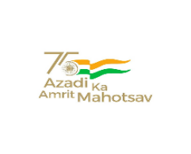
PM SHRI KENDRIYA VIDYALAYA RUBBER BOARD, KOTTAYAM
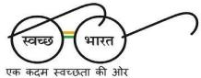
फोन/ PHONE 0481-2351807 KV CODE:1793
ईमेल/Email : kvkottayam@yahoo.co.in CBSE CODE:79041
वेब/Web :rbkottayam.kvs.ac.in. CBSE AFF NO: 900022

F.2-18/KVKTM/2024-25/ Date: 19.04.2024

ADMISSION NOTICE(No.1) FOR BALVATIKA-3 Dated 19.04.2024
Schedule for Verification of documents for Balvatika-3-2024-25
Sl No. | Quota/Category | Date of submission of documents
1 | RTE QUOTA CATEGORY1 & CwSN | 20/4/2024
2 | CATEGORY 2 | 22/4/2024 TO 24/4/2024
3 | SC/ ST QUOTA | 27/4/2022

- The following documents should be brought for verification

i) Original Birth Certificate
ii)Original SC/ST/OBC NCL/EWS/BPLCertificates (if applicable)
  - Residence Certificate/Proof
  - For Ex-Service, discharge documents
  - Distance declaration (only for RTE)
(viii)Aadhar card of the child
- The total fee payable is Rs 1525 (VVN @ Rs 500 per month for three months from April to June 2022 and admission fee of Rs 25).
- No fee to be paid for RTE.
- Parents should come to the Vidyalaya (preferably both) along with the child for document verification and completing the admission procedure.

I/C PRINCIPAL

