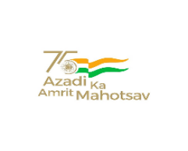 | केंद्रीय विद्यालय रबर बोर्ड कोट्टयम-686009,केरल.  KENDRIYA VIDYALAYA RUBBER BOARD , KOTTAYAM  KERALA- 686009  फोन/ PHONE 04812351807 फाक्स/Fax No: 2351807 ईमेल/Email:kvkottayam@yahoo.co.in  वेब/Web:rbkottayam.kvs.ac.in.

F. II-18/KVKTM/2023-2024/ Date: 14.08.2023

VACANCIES FOR BAL VATIKA-3

Registration is open from 14/8/2023 to 19/8/2023 for ONE(01) GENERAL vacancy and THREE (03) vacancies under SC/ST QUOTA for admission to Bal Vatika-3 for the academic session 2023-24.
Registration form may be collected from school between 10:00 am and 3:00 pm on working days.
Last date for submitting the duly filled registration form along with supporting documents is 19/8/2023 before 1:00 pm.

DOCUMENTS TO BE SUBMITTED FOR REGISTRATION

- Duly filled Registration form
- Copy of Birth Certificate
2. Caste Certificate in parent’s name or child’s name
3. Residence Certificate or proof
5. Copy of Aadhar card of the child.

OFFG/ PRINCIPAL

