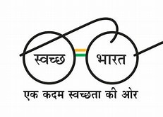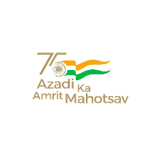 | केंद्रीय विद्यालय रबर बोर्ड कोट्टयम-686009,केरल.  KENDRIYA VIDYALAYA RUBBER BOARD , KOTTAYAM  KERALA- 686009  फोन/ PHONE 04812351807 फाक्स/Fax No: 2351807 ईमेल/Email:kvkottayam@yahoo.co.in  वेब/Web:rbkottayam.kvs.ac.in.

F. II-18/KVKTM/2023-2024/ Date: 25.07.2023

NOTICE

An offline Draw of Lots for Bal Vatika-3 Admission 2023-24 will be held in the Vidyalaya on 26.07.2023 at 9.00 am. The Chairman VMC has constituted the following Committee to monitor the draw of lots.

1 | PRINCIPAL | Dr JOY JOSEPH (CONVENER)
2 | TEACHER | Mrs. SANDHYA VISWANATHAN
3 | PARENT REPRESENTATIVE | Mrs SEETHALAKSHMI K C
4 | PARENT REPRESENTATIVE | Mr. ARUN K V
5 | VMC MEMBER | Prof. BIJU K

PRINCIPAL

